**Shining a Light on Global Warming and the Blindness of Politics**

**David Kinney**

Bellevue University

Bellevue, NE 68005

dakinney@my365.bellevue.edu

|  |
| --- |
| Permission to make digital or hard copies of part or all of this work for personal or classroom use is granted without fee provided that copies are not made or distributed for profit or commercial advantage and that copies bear this notice and the full citation on the first page. Copyrights for third-party components of this work must be honored. For all other uses, contact the Owner/Author.    Copyright is held by the owner/author(s). |

# Abstract

In this paper I hope to shed light on two main topics. First, the conclusive data proving that global warming is a real thing, backed by concrete facts and figures. Second, the politicians—overwhelmingly conservative—who discount global warming as a hoax; and further, the Big Oil and industry lobbyists who finance these politicians to propagate this stance.

**Author Keywords**

Global Warming; Politics; Climate; Lobbyists

**ACM Classification Keywords**

Social and professional topics~Government technology policy

# Introduction

The data proving the case for global warming would appear to be overwhelming. Yet politicians the world over continue to dismiss it as a myth or the voice of hysterical “tree huggers”. While this should come as no surprise, one only needs to look under the rocks to find the fossil fuel and industrial companies that feed the political machine. It is in their best interests to keep the perception of global warming as a myth in the minds of the voting public.

# The Science

# Data exists that proves that *every* year of the past 40 years has been warmer than the 20th century average. Further, 2016 was the hottest year on record as far back as records exist. The 12 warmest years on record have all occurred since 1998.

# Globally, the average surface temperature has increased more than one degree Fahrenheit since the late 1800s and the majority of that increase has occurred over the past three decades.

# 

# *Source: Greg Shirah*

# The primary cause is the overloading of Earth’s atmosphere with carbon dioxide. This causes heat to be trapped in the atmosphere and steadily drives up the planet’s temperature. Where does all this carbon come from? The fossil fuels we burn for energy—coal, natural gas, and oil—plus the loss of forests due to deforestation, especially in the tropics.

# Impacts

Global warming is accelerating the rate at which sea level is rising. The effect is a dramatic increase in coastal flooding risk, predominantly on the U.S. East Coast and Gulf of Mexico. Wildfires are increasing, and wildfire season is getting longer in the Western U.S. as temperatures rise.

Dangerously hot weather is on a steady rise as well, and is occurring more frequently than it did in the mid-20th century.

In addition, climate change has significant negative implications for public health, including increased air pollution and a longer and more intense allergy season. Finally, as temperatures continue to increase, the volume of rain falling during the heaviest downpours increases the risk of flooding.

|  |
| --- |
| **Table 1: Research**  **Questions**   1. What data can we ascribe as conclusive as opposed to speculative? 2. Taking that one step further, does the data conclusively prove such things as, the increase in wildfires, heat waves, and health impacts, or are some or all of these outcomes coincidental? 3. In the same vein, can we make the connection between corporate contributions to political candidates who have come out against the efficacy of global warming? 4. Conversely, can we also make the case that those politicians who recognize global warming as having no contributions from these same corporations? |

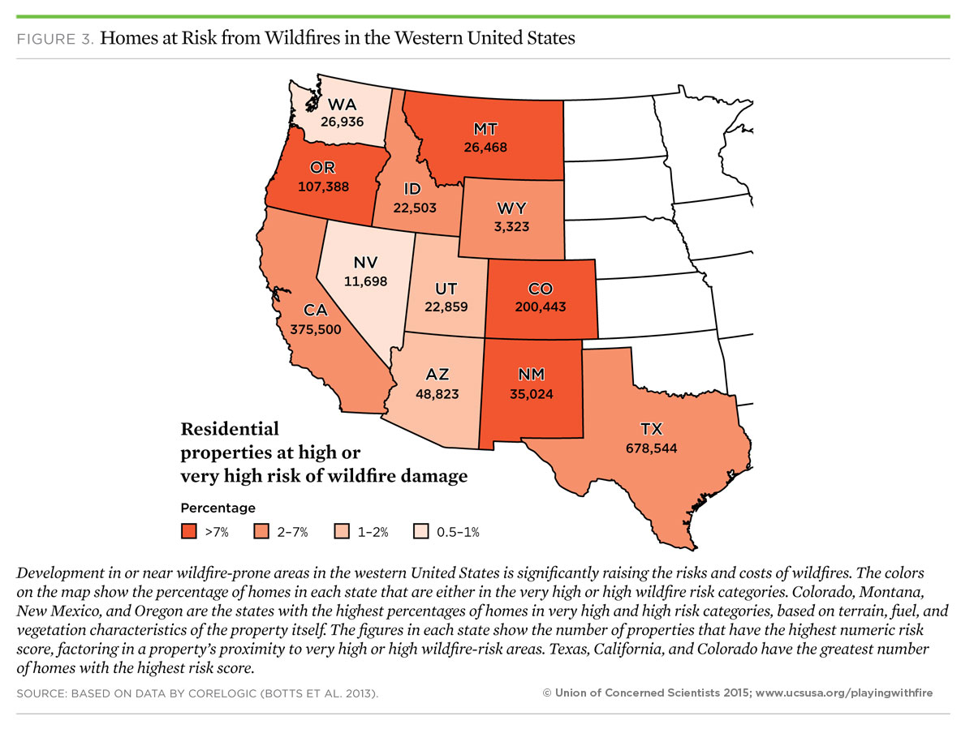

# Misinformation and Political Denial

|  |
| --- |
|  |

Major fossil fuel companies have been aware of their impact on global warming for upwards of three decades. Further, many of the conclusive results came from their own scientists. Thus began a campaign of misinformation directed at shareholders, the public, and politicians.

Media companies that show a decidedly conservative political bias add to the misinformation.

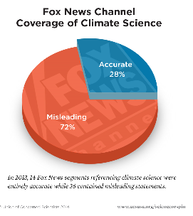

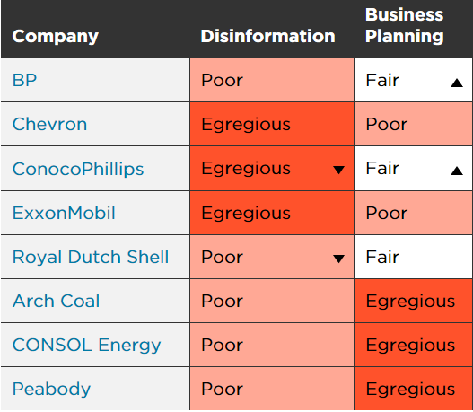

Source: 2018 Climate Accountability Scorecard

Union of Concerned Scientists

On June 1, 2017, President Trump announced that the U.S. would cease all participation in the 2015 Paris Agreement on climate change mitigation, stating that the accord will undermine the U.S. economy and puts the U.S. at a permanent disadvantage. Following President Trump's declaration, Vice President Mike Pence commented that Trump "demonstrated real leadership" and said that he doesn't understand why Democrats and liberals in the United States and the left around the world care about climate change. (Sampathkumar, Mythili June 2, 2017)

What conclusions are we to draw from such actions and statements? Is it any great secret what industries Mr. Trump was referring to in his statement about undermining the U.S. economy? I would have to conclude that it is the very same industries that are the direct contributors to global warming.

# Acknowledgements

I would like to thank Catherine Williams, Michael Eller, Max Tegmark, Christof Hoch, and Al Sweigart for the education and guidance they have provided me. I want to especially thank Annette Joy Kinney for putting up with the many hours I spend with my head in a book or laptop. And here is a shameless picture of my “children”, Tank, Pi, Sydney and Brutus.

# References

1. http://www.un.org/en/sections/issues-depth/climate-change/
2. https://www.ucsusa.org/global-warming
3. https://climate.nasa.gov/
4. https://www.livescience.com/37057-global-warming-effects.html
5. https://www.carbonbrief.org/analysis-the-most-cited-climate-change-papers
6. https://www.ucsusa.org/global-warming#.W9o3f5NKiwc
7. <https://quadrant.org.au/magazine/2015/06/climate-wars-done-science/>
8. Sampathkumar, Mythili (June 2, 2017). "Vice President Mike Pence says climate change is just an issue for the left". The Independent. New York. Retrieved June 12, 2017.
9. https://en.wikipedia.org/wiki/United_States_withdrawal_from_the_Paris_Agreement#cite_note-Sampathkumar-59